What are Natural Fibres?
‘Natural fibre’ is a term used to refer to the fibres that are obtained from (or are produced by) animals and plants. These fibres have a wide range of applications in the manufacture of composite materials. Paper and felt (a type of textile material) can be prepared by matting different layers of natural fibres into sheets.
Most natural fibres are known to be good absorbers of sweat and other liquids. A wide range of textures can be obtained from different natural fibres (either individually or through a combination of two or more natural fibres). For example, cotton fibres (which are natural fibres that are derived from the cotton plant) are used in the production of cotton fabrics that are characterised by their relatively low weight and their soft texture. Another advantage of cotton fibre is that it can be woven into the clothing of various sizes and colours. Clothing which is made up of natural fibres (like cotton) is usually preferred over clothes that are made up of synthetic fibres, especially by the people who live in hot and humid regions.

Examples of Natural Fibres
Natural fibres are broadly classified into two categories – Plant fibres and animal fibres. Examples for both plant fibres and animal fibres have been provided in this subsection.

Plant Fibres
- Seed fibres – the fibres obtained from the seeds of different types of plants.
- Leaf fibres – the natural fibres that can be collected from the leaves of certain plants. Examples include pineapple and banana leaf fibres.
- Fruit fibres – the natural fibres that are obtained from the fruit of a plant (coconut fibre, for example).
- Stalk fibres – the natural fibres that are obtained from the stalks of certain kinds of plants. Examples include wheat straws, bamboo fibres, fibres obtained from the stalk of rice and barley plants, and straw.
- Bast fibres – the natural fibres that are obtained from the cells belonging to the outer layer of the stem. Examples of bast fibres include jute fibres, flax fibres, vine fibres, industrial hemp fibres, kenaf fibres, rattan fibres, and ramie fibres. It can be noted that these fibres are widely used in fabric and packaging due to their durable nature.

Animal Fibres
Animal fibres are natural fibres which usually contain proteins like fibroin, keratin, and collagen. Common examples of animal fibres are listed below.
- Silk – animal fibres that are obtained from silkworms (different species produce different types of silk).
- Sinew – animal fibre that connects the muscles of certain animals to their bones.
- Wool – animal fibre that is obtained by shearing off the fur of certain breeds of sheep.
- Mohair – animal fibre crafted from the hair of the Angora goat.

Applications of Natural Fibres
Natural fibres, including certain glass fibres, are widely used in the construction industry in certain construction materials. Such composites (can also be referred to as biocomposites), even when placed in a matrix of synthetic polymers, can still be considered natural fibres. Cellulose fibre has a wide range of applications spanning several industries such as the automobile and electronics industry. These natural fibres can be used for insulation and for noise-absorbing panels.
When it comes to industrial value, the four most prominent animal fibres are silk, wool, angora, and camel hair. Many plant fibres also have vital industrial applications. For example, cotton fibre is an integral raw material for the textile industry. Other important plant fibres in the industry include hemp fibre, jute fibre, and flax fibre.
Furthermore, natural fibres may have applications in medicine since they can help in the manufacture of biomaterials. For example, the natural fibre Chitin can be used to remove certain toxic pollutants from industrial water discharge.
To learn more about natural fibres and other related concepts, register with BYJU’S and download the mobile application on your smartphone.
Classification of Natural Fibres:
Natural fibres can be classified based on their origin, which includes plant, animal and mineral fibres.
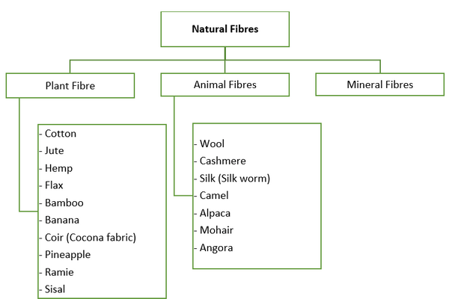Fig: Classification of natural fibres
- Plant fibres: Plant fibres are obtained from the stem, leaves, and bark of various plants. Examples include cotton, hemp, flax, jute, ramie, bamboo, and sisal.
- Animal fibres: These fibres are obtained from the hair, fleece, or silk of various animals. Examples include wool, silk, alpaca, llama, and angora rabbit.
- Mineral fibres: Mineral fibres are obtained from minerals. Examples include asbestos and glass fibres.
- Microorganism fibres: Those are obtained from microorganisms, such as algae and bacteria.
- Cellulosic fibres: These fibres are made from cellulose, the main component of plant cell walls. Examples include cotton, flax, and hemp.
- Protein fibres: These fibres are made from protein, and are typically obtained from animals. Examples include wool and silk.
- Natural composite fibres: Composite fibres are made from a combination of different materials, such as wood fibres mixed with resin, or coconut fibres mixed with rubber.
Types of Natural Fibres:
There are many types of natural fibres, each with their own unique properties and uses. Here are some examples of common natural fibres:
- Cotton: One of the most widely used natural fibres, cotton is known for its softness, breathability, and absorbency. It is used to make clothing, home textiles, and industrial fabrics.
- Wool: Derived from the hair of sheep, wool fibres are naturally crimped, providing insulation and elasticity. It is used to make clothing, blankets, and carpets.
- Silk: Produced by silkworms, silk fibres are smooth and lustrous, making them popular for clothing and home textiles.
- Hemp: A strong, durable fibre made from the stem of the hemp plant, used for rope and other industrial applications.
- Flax: Fibres from the flax plant are strong and stiff, and are used to make linen fabrics.
- Jute: Jute is a natural vegetable fibre which is produced from the stem of the plant Corchorus olitorius and Corchorus capsularis.
- Ramie: Ramie is a natural vegetable fibre which is made from the stem of the plant Boehmeria nivea.
- Coir: Coir is a natural fibre that comes from the husk of coconuts.
- Sisal: Sisal is a natural fibre that comes from the leaves of the Agave sisalana plant.
- Bamboo: Bamboo fibres are strong and durable, and are often used in textiles and building materials.
- Alpaca, Llama and Angora rabbit: Fibres obtained from these animals are used for making clothing, blankets, and other textile products.
- Wood: Fibres obtained from trees and other woody plants can be used to make a wide variety of products, including paper and building materials.
- Seaweed and Shells: Natural fibers can be obtained from seaweed and shells, used for making textiles, rope, and other products.
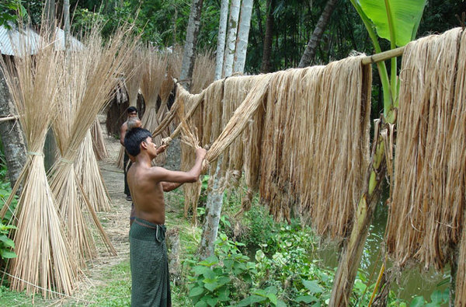Fig: Jute fiber
Properties of Natural Fibres:
Properties of natural fibres include:
- Biodegradable: Natural fibres can decompose naturally, reducing the environmental impact of disposing of them.
- Renewable: These are produced from plants and animals that can be replenished.
- Absorbent: Natural fibers can absorb moisture and release it again, making them comfortable to wear in warm and humid climates.
- Strong and durable: They are strong and durable, making them suitable for a variety of applications.
- Insulative: Natural fibres can provide insulation, helping to keep the body warm in cold weather.
However, natural fibres also have some drawbacks:
- Shrinkage: Natural fibre can shrink when exposed to heat or moisture, leading to changes in the fit and shape of clothing and other products made from them.
- Wrinkling: These fibres can wrinkle easily and may require ironing or steaming to restore their shape.
- Pilling: Fabric from natural fibers can pill, or form small balls on the surface, after repeated wear and washing.
- Cost: More expensive than synthetic fibres due to the cost of growing and harvesting them.
Uses of Natural Fibres:
Natural fibres have a wide range of uses due to their unique properties and characteristics. Some examples include:
- Textiles: Natural fibres like cotton, wool, silk, and linen are commonly used to make clothing, bedding, and other textiles. They are also used in the production of nonwoven fabrics, technical textiles and industrial textiles.
- Rope and twine: Hemp, jute, and sisal are strong and durable, making them ideal for use in rope and twine.
- Paper: Wood, bamboo, and hemp are used to make paper products, such as books, newspapers, and packaging materials.
- Building materials: Bamboo, hemp, and flax fiber can be used to make building materials like insulation, flooring, and roofing materials.
- Biocomposites: Natural fibres can be used as reinforcement in biocomposites materials, like wood-plastic composites, natural fibre reinforced plastics, and natural fibre reinforced concrete.
- Agriculture: Coir and sisal fibers are used to make twine and rope for agricultural applications, such as tying plants to stakes or trellises, and for making biodegradable mulch mats.
- Automotive: Natural fibres like flax and hemp are used in the automotive industry as reinforcement in biocomposite materials in the body and interior of the cars.
- Personal Care: Bamboo, hemp and cotton are used in the production of sanitary products, wipes, and other personal care items.
- Industrial Products: Jute, sisal, and coir are used for making various industrial products such as mats, geotextiles, and abrasive products.
- Home Textile: Bamboo, seagrass, and sisal are used to make home décor items like rugs, baskets, and placemats.
- Fashion Accessories: Silk, wool and alpaca are used to make fashionable accessories like scarfs, hats, and gloves.
- Sports and recreation: Hemp and bamboo are used to make gear such as skateboards, snowboards, and surfboards.
As the technology advances, new applications are constantly being developed, making natural fibres increasingly valuable and versatile.
References:
- Principles of Spinning: Fibres and Blow Room Cotton Processing in Spinning by Ashok R. Khare
- Textile Raw Materials By Ajay Jindal and Rakesh Jindal
- Textile Engineering – An Introduction Edited by Yasir Nawab
- Fibres to Fabrics by Bev Ashford
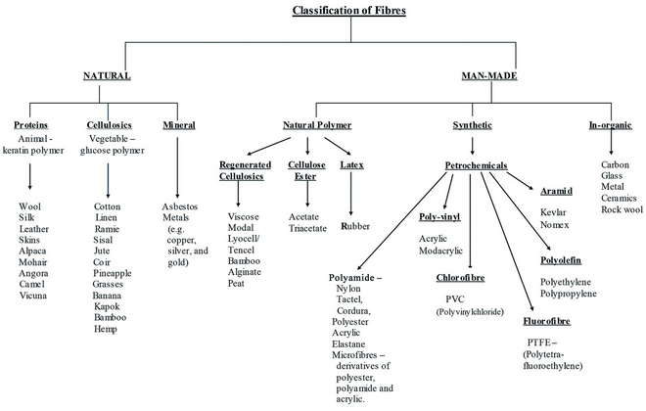

Classification of Textile Fibres
Fiber
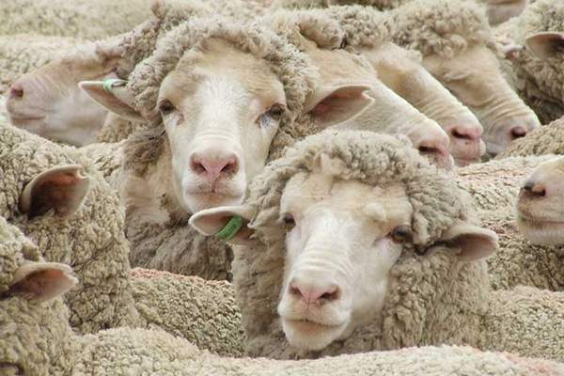

Animal Fibres: Properties, Types and Uses
Fiber
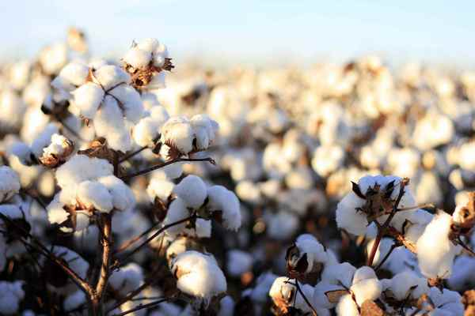

Cotton Fibre: Types, Properties and Uses
Fiber
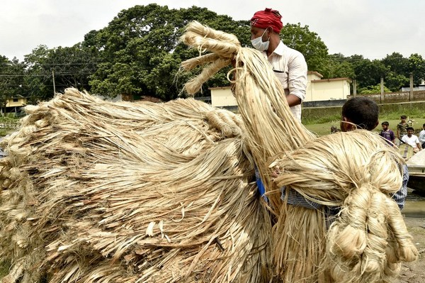

Properties and Uses of Jute Fibre
Fiber

10 Different Types Of Natural Fibers With Pictures
By Alex Assoune
You can find natural and synthetic fibers among the world's most used fibers for textiles. Natural fibers can either be plant-based, animal-based, or mineral-based.
Plant-based fiber types include seed fibers like cotton, bast fibers like hemp, core fibers like jute, leaf fibers like abaca, fruit fibers like coconut, stalk fibers like wheat, cane, grass, and reed fibers like bamboo.
Commonly used animal-based fibers for fashion include wool or hairs and silk fibers. You might also have heard of other wool types like angora, cashmere, alpaca, and mohair.
Here is a list of different types of natural fibers and their uses and properties with examples and pictures.
Panaprium is proud to be 100% independent, free of any influence, and not sponsored. We carefully handpick products from brands we trust. Thank you so much for buying something through our link, as we may earn a commission that supports us.

1. Cotton
Cotton is the most widely used natural fiber worldwide and one of the cheapest to produce. And it's the second most used fiber for garment production behind polyester globally.
Cotton has been used for over 7,000 years to make clothes since it offers numerous advantages for fabric production. About half of all textiles contain natural cotton fibers.
Cotton has a low price because it's mass-produced globally. It's the most widespread profitable non-food crop.
Cotton is easy to clean, soft, durable, lightweight, breathable, and absorbent. It's a natural material, bio-based, biodegradable, compostable, and recyclable.
Dying cotton fabrics is also effortless, fast, and in a variety of long-lasting colors. Cotton fabrics regulate body temperature very well and are perfect in hot weather to keep you cool and fresh.
Cotton harvesting begins at the cotton plant bolls. Cotton is then processed and combed into yarn. But the cotton plant requires tons of water, pesticides, and fertilizers to grow.
Regular cotton production isn't ecological, ethical, or sustainable. It drains resources, generates waste, involves harmful substances that ruin biodiversity and soil fertility, and endanger human health.
Many intensive farming operations genetically modify cotton fibers to increase their productivity and resist pests.
You can read our article on conventional cotton fibers to learn more about their disastrous environmental impact.

2. Flax
Flax is a popular natural fiber harvested from the flax plant. Textile manufacturers used flax to make linen, a very sustainable material that is breathable, soft, comfortable, and luxurious.
Linen has been used for a very long time to make clothing. It's an old fabric, much more ancient than cotton. In today's market, linen is more expensive than cotton because of its costly manufacturing.
Flax represents less than 1% of all textile fibers consumed worldwide. It has been used for thousands of years to make linen textiles that wrap mummies in ancient Egypt to help with preservation.
Flax plants grow in many different countries around the world. Natural flax fibers are extracted from the plant, spun into yarn, then woven into linen fabric. Europe produces more than 85% of all flax fibers globally.
The flax plant has an overall low water footprint. It requires very little water to grow unless the weather is warm and dry.
In history, linen cloth symbolized luxury, preciousness, and extravagance. It was found at dining tables in the Middle Age as a symbol of power, to exhibit authority and wealth.
Today, linen is expensive because it's hard to weave. Its manufacturing is a laborious and timely process. Since natural flax fibers easily break, the machinery must run very slow.
Linen fabric production costs twice as much as cotton production. Flax plants cannot be mowed but pulled up by the roots. It can take up to 90 days to harvest flax.
Many fashion brands and designers use natural flax fibers to make a wide range of other products such as household articles, including pillows, curtains, bath towels, rugs, and wall coverings.
Check out our article on the popularity of linen for more information about natural flax fibers and their uses.

3. Hemp
Hemp is one of the most environmentally friendly natural fibers in the world. It's a great material to create comfortable textiles and beautiful fashion with fantastic qualities.
Hemp is soft, breathable, lightweight, and durable but wrinkles easily. It's also expensive to produce, difficult to dye, and overshadowed by cotton.
Hemp is one of the oldest natural fibers used for textiles in the world. Talented artisans already used hemp 10,000 years ago to make clothing.
Hemp plants grow quicker and easier than most trees in temperate climates. They have a very high yield since one acre of hemp can produce two to three times more fiber than an acre of cotton.
Hemp also requires little water to grow and almost no pesticides or fertilizers. Textiles made from hemp fibers are natural, bio-based, and biodegradable.
Natural hemp fibers are strong, longer, more absorbent, and more resistant than cotton fibers. They don't benefit from the same popularity as cotton due to low availability and costly production.
You can read our article on the pros and cons of hemp as a natural textile fiber to learn more about its properties and uses.

4. Ramie
Ramie is a long-lasting and enduring natural fiber. It's lightweight and breathable like cotton and linen but not very flexible or elastic.
Textile manufacturers make ramie fabric with natural fibers extracted from the Ramie plant. It's a very eco-friendly and sustainable fabric, great for the eco-conscious shopper.
Ramie originates from China, India, and Indonesia and is one of the oldest fiber crops. Farmers have used natural ramie fibers for thousands of years, mainly for fabric production and weaving clothing.
Ramie fibers are fantastic cotton substitutes with rising popularity. They are very versatile and used to create dresses, sweaters, skirts, jackets, suits, shirts, blouses, pants, jeans, or sportswear.
Ramie's production process is very similar to the one used for linen. Ramie isn't widespread because it remains expensive due to labor costs during cultivation and production. The cheaper alternatives are cotton and linen.
Check out our article on ramie fabric for more information about natural ramie fibers and their uses.

5. Jute
Jute is an environmentally friendly fiber used for textile manufacturing and clothing weaving. It's also one of the cheapest natural fibers and the most widely used globally after cotton.
Jute fabric is strong, durable, and eco-friendly, with a natural look and feel. It has high density, heat resistance, and moisture retention. It's mainly composed of cellulose and lignin, components of plant and wood fiber.
Farmers collect jute fiber from the bast or skin of the jute plant. There are many different types of jute fibers made from different botanical varieties of jute.
Jute plants require lots of rainfall, a warm and humid climate and take about 120 days to grow from April to August. They typically grow in tropical lowland areas with humidity above 60% without pesticides or fertilizers.
Jute is one of the longest natural fibers, harvested in single long strings, 1 to 4 meters long, and a diameter from 17 to 20 microns.
Natural jute fibers are widespread in India, China, Pakistan, Bangladesh in clothing, cordage, and packaging. It's widely used in agriculture and also for handbags, shopping bags, luggage, and wallets.
You can also find jute in filters, geotextiles, decorative items, and home furnishings such as carpets, curtains, canvas, rugs, coverlets, and containers.
You can read our article on eco-friendly jute fabrics to learn more about this great alternative to reduce textile environmental impact.

6. Abaca
Abaca is a natural plant-based fiber used to make eco-friendly textiles. It's a versatile material used in many different applications, including clothing fabrics in the fashion industry.
Abaca is a leaf fiber that comes from Abaca plants (Musa Textilis). The abaca plant is native to the Philippines and is quite similar to banana trees.
Abaca fabric is highly durable, long-lasting, and breathable. It's carefully hand-woven on traditional wooden looms by villagers in the southern island Mindanao of the Philippines.
You can commonly find natural abaca fibers in packaging material for agricultural products, bags, luggage, and wallets. Manufacturers also use abaca for cordage, filters, geotextiles, and decorative items such as canvas, rugs, carpets, and curtains.
Abaca is a multifunctional and traditional matting product that is also 100% eco-friendly and recyclable. Abaca is used in many applications and is safe to place in an indoor or outdoor environment.
Check out our article on abaca fabric for more information about natural abaca fibers and their uses.

7. Bamboo
Bamboo is a natural fiber considered eco-friendly. It's a very sustainable, fast-growing crop that requires almost no fertilizer, pesticides, labor, or additional water.
Unfortunately, natural bamboo fibers very rarely make textiles directly by mechanically processing the plant stem. The process isn't commercially viable. And finding this kind of textile is a difficult task.
Generally, textiles advertised as bamboo aren't natural but semi-synthetic, rayon-like fabrics made from regenerated cellulose extracted from bamboo.
Most bamboo fabrics available in the market are bamboo rayon or viscose made of natural cellulosic polymers from bamboo. The manufacturing of textiles from bamboo requires heavy processing and is usually very toxic.
Manufacturers disintegrate bamboo fibers into a viscous liquid before reconstructing them into thin threads and spinning them into yarns.
Bamboo rayon or bamboo viscose fabrication consumes large amounts of resources and hazardous chemicals such as carbon disulfide, sulfuric acid, ammonia, acetone, or caustic soda.
You can read our article on bamboo fabrics to learn the truth about its manufacturing and environmental impact.

8. Pineapple
Pineapple is a natural plant-based fiber made of cellulose extracted from pineapple leaves. The material makes good use of pineapple waste by offering a more ethical alternative to animal leather.
Ananas Anam is the company behind Piñatex, a pioneer in leather alternatives made from pineapple leaf fiber. More than 500 clothing manufacturers have used Piñatex since its commercial launch in 2015.
Pineapple leather allows farmers to generate additional income by sorting and selling long leaves suitable for fiber production instead of burning them or leaving them to rot.
Pineapple is one of the most productive tropical fruit plantations in the world. One acre of pineapple plantation can produce 20,000 fruits every 15 months.
But pineapple only flower and fruit once, so the plant and its leaves are a waste product after harvest. The long fibers from pineapple plants are widely used in the fashion and furniture industry today.
Check out our article on Piñatex pineapple leather for more information about natural pineapple fibers and their uses.

9. Wool
Wool is an animal-based fiber obtained from sheep, goats, muskox, rabbits, or camelids. It's often used in the fashion industry to make warm, technical clothing, such as socks, gloves, coats, pullovers, jackets, sweaters, and more.
Wool is a textile fiber made of animal proteins and lipids. Many types of wool fabrics exist, including shearling, alpaca, cashmere, mohair, and angora.
However, wool production has a disastrous impact on the environment. The farming and processing of wool pollute the air, soil, and water, producing greenhouse gases and wastes.
More than 95% of all wool comes from mass production globally. And mass production isn't ethical or sustainable. Wool fiber is one of the five most environmentally damaging fibers worldwide.
Animals used for wool farming are enslaved, exploited, subjected to painful treatments, and exposed to dangerous substances with long-term disastrous effects on ecosystems and human health.
We encourage you to read our article on the harmful effects of wool production to learn the truth about its environmental impact.

10. Silk
Silk is luxurious, natural, and considered one of the finest fibers worldwide. The most expensive silk is mulberry silk, made from the caterpillar cocoons that eat mulberry leaves over several weeks in their pupal stage.
There are many different types of silk. It depends on the animal species, what the insects eat, and the country of origin. But mulberry silk is the finest and contributes around as much as 90% of silk production.
Silk fibers come from several insects called silkworms. Manufacturers commonly use the silk of moth caterpillars to make textiles. Other animals such as leafhoppers, flies, ants, wasps, bees, beetles, and spiders can also produce silk.
Silk has a soft hand feel and a shiny look. It's comfortable, smooth, versatile, breathable, durable, and resistant.
Unfortunately, silk production is very cruel to animals as it destroys hundreds of thousands of sensitive silkworms every year to harvest silk from their cocoons.
Silkworms are killed in boiling water during their pupal stage to preserve material quality, thread length, and value. Whereas in nature, silkworms chew their way out of their cocoon when they become adults.
Check out our article on silk animal cruelty for more information about silk production and its impact.

Was this article helpful to you? Please tell us what you liked or didn't like in the comments below.

